INTERNSHIP REPORT

“ExamGuard AI – AI-Powered Online Examination Management Platform”

BACHELOR OF ENGINEERING
in

INFORMATION TECHNOLOGY
By
Om Chandrakant Deo
Roll No.: T51020
Under Supervision of
Mr. Aadarsh Shinde
Senior Technical Trainer

Rubicon Foundation, Pune

(Duration: From / / 2026 to / / 2026)

DEPARTMENT OF INFORMATION TECHNOLOGY

ZEAL COLLEGE OF ENGINEERING AND RESEARCH, PUNE
Academic Year 2025-26

ZEAL COLLEGE OF ENGINEERING AND RESEARCH, PUNE



CERTIFICATE

This is to certify that the Internship Report submitted by Om Chandrakant Deo (Roll No.: T51020) is a record of the work carried out by her during the academic year 2025–2026, in partial fulfillment of the requirements for the award of the degree of Bachelor of Engineering in Information Technology. The internship training was successfully completed at Rubicon Foundation, Pune

Internship Coordinator Mr. Aadarsh Shinde Head of the Department Department Internship Trainer

Place: - Pune
Date: -

INSERT INTERNSHIP OFFER LETTER HERE, “Remove This line after inserting”

INSERT INTERNSHIP CERTIFICATE HERE, “Remove This line after inserting”

ACKNOWLEDGEMENT

With immense pleasure, I am presenting this report on internship work on “ExamGuard AI - AI-Powered Online Examination Management Platform” as a part of the curriculum of T.E. Information Technology at ZEAL COLLEGE OF ENGINEERING AND RESEARCH, PUNE. It gives me proud privilege to complete this report work under the valuable mentorship of Mr. Aadarsh Shinde and Prof. Wrushabh Shirsat.
I am also extremely grateful to Prof.Balaji Chaugule, H.O.D of Information Technology and
Dr. Ajit Kate, Principal Zeal College Of Engineering And Research, Pune for providing all facilities and help for smooth progress of report work.

I would also like to thank all the Staff Members of Information Technology Department, Management, friends, and my family members, who have directly or indirectly guided and helped me for the preparation of this Report and gave me an unending support right from the stage the idea was conceived

Signature
Student Name: Om Chandrakant Deo
Roll No: - T51020

ABSTRACT

THE COMPANY:
The internship was carried out at Rubicon Foundation, a technology-driven organization focused on software product development and digital solutions. The company provided a professional and collaborative environment that enabled hands-on learning in full-stack web development and AI-powered application design, bridging academic concepts with real-world implementation.

PROGRAMMERS AND OPPORTUNITIES:
The internship offered valuable opportunities to work with industry-standard technologies such as React 18, FastAPI, MongoDB, and cloud platforms. Collaboration with experienced developers provided practical exposure to modern software engineering practices, including Agile development, code reviews, version control using Git, and cloud deployment pipelines on Render and Vercel, thereby enhancing both technical and professional competencies.

METHODOLOGY:
The project was developed using an Agile iterative methodology, where tasks were divided into structured weekly sprints. Each sprint focused on delivering specific functional modules—such as authentication, examination management, proctoring, and analytics—followed by thorough testing, integration, and review to ensure system reliability and performance.

KEY PARTS OF THE REPORT:
- Company Background Information
- Introduction to Domain — AI-Powered EdTech & Online Examination Systems
- Responsibilities and Contributions During the Internship
- Experience and Technical Skills Acquired
- Detailed Project Report with Screenshots
- Outcomes and Learnings
- Conclusion and Future Scope

WEEKLY OVERVIEW OF INTERNSHIP ACTIVITIES

1st WEEK | DATE | DAY | NAME OF THE TOPIC/MODULE COMPLETED

2nd WEEK | DATE | DAY | NAME OF THETOPIC/MODULE COMPLETED

3rd WEEK | DATE | DAY | NAME OF THE TOPIC/MODULE COMPLETED

4th WEEK | DATE | DAY | NAME OF THE TOPIC/MODULE COMPLETED

INDEX

Sr. No. | Title | Page no.
1. | Company Background Information | 2
2. | Introduction to domain | 3
3. | Responsibilities during the internship | 4
4. | Experience and skills acquired during internship | 5
5 | Internship Report & Screenshots | 6
6. | Outcomes | 18
7. | Conclusion | 19
8. | Appendix A: Internship Request Letter | 20
9. | Appendix B: Internship Permission Letter | 21
10. | Appendix C: Daily work sheet
11. | Appendix D: Assignments during internship
12. | Appendix E: Internship Certificate

Learning Objectives/Internship Objectives

Company Background Information

Rubicon Foundation is a technology-driven organization based in Delhi, focused on developing innovative software solutions for the education and enterprise sectors. The company specializes in full-stack web application development, cloud computing, and AI integration, delivering scalable and efficient digital solutions to a diverse range of clients.
Founded in 2006, the organization has grown into a team of skilled engineers and designers dedicated to building secure, reliable, and user-friendly applications. Rubicon emphasizes modern development practices, leveraging emerging technologies to address real-world challenges across industries.
The internship program at Rubicon Foundation is structured to provide engineering students with hands-on project experience, enabling them to work on real-world applications under professional mentorship. This approach helps bridge the gap between academic learning and industry expectations while fostering technical and problem-solving skills.

Introduction to domain

The domain of this internship lies in AI-Powered EdTech, with a primary focus on advanced Online Examination Management Systems and Learning Management Systems (LMS). In recent years, the rapid expansion of digital education, remote learning environments, and global accessibility to online resources has significantly transformed the traditional education landscape. This transformation has created a growing demand for intelligent platforms that not only deliver educational content but also ensure secure, scalable, and efficient assessment mechanisms.
Modern EdTech systems are evolving beyond basic content delivery by integrating Artificial Intelligence (AI) to enhance both learning and evaluation processes. These platforms now incorporate features such as automated proctoring, behavioral analytics, adaptive assessments, and real-time performance tracking, enabling institutions to maintain academic integrity while providing a personalized learning experience.
A critical aspect of this domain is the development of secure online examination environments, where technologies like behavioral biometrics, anomaly detection, and activity monitoring are used to identify suspicious patterns and prevent malpractice without relying solely on intrusive methods such as video surveillance. This ensures a balance between privacy, fairness, and security.
Additionally, Learning Management Systems are becoming more interactive and learner-centric by offering structured courses, integrated quizzes, coding assessments, progress tracking, and analytics dashboards. These features help educators make data-driven decisions while allowing students to monitor their growth and improve their skills effectively.
Overall, AI-powered EdTech platforms aim to create a seamless ecosystem that combines learning, assessment, monitoring, and analytics into a unified system, thereby enhancing the quality, accessibility, and credibility of digital education.

Responsibilities during the internship

As an intern working on the ExamGuard AI platform, I contributed to the development of a full-stack AI-powered examination and learning management system, focusing on backend development, frontend implementation, system integration, and deployment.
I designed and implemented RESTful API endpoints using FastAPI to handle core functionalities such as user authentication, exam management, course operations, and submission processing. On the data layer, I developed MongoDB models using Beanie ODM and Motor, enabling efficient and asynchronous database interactions for collections like users, exams, courses, and submissions.
I implemented a secure authentication system using JWT-based role-based access control for both student and admin portals, along with bcrypt password hashing to ensure secure credential management. Additionally, I integrated the Judge0 API to support coding assessments, allowing secure execution and evaluation of user-submitted code against predefined test cases.
A key contribution was in building the proctoring module, which included tab-switch detection, paste monitoring, and behavioral logging to identify potential malpractice during exams while maintaining a privacy-friendly approach.
On the frontend, I developed responsive and user-friendly interfaces using React 18 and Tailwind CSS, covering dashboards, exam pages, and course modules for both admin and student portals. I also implemented analytics dashboards using Recharts to visualize performance metrics and system insights.
Furthermore, I participated in Agile development practices, including sprint discussions and code reviews, and managed deployment configurations using Render (backend) and Vercel (frontend) to ensure smooth production readiness.
Through these responsibilities, I gained practical experience in building scalable, secure, and intelligent EdTech solutions across the full development lifecycle.

Experience and skills acquired during internship

Technical Skills Acquired:
- Full-Stack Development: Built end-to-end web applications using React 18 and FastAPI, ensuring smooth frontend-backend integration.
- Asynchronous Programming: Gained practical experience with async/await in FastAPI and Motor for efficient, non-blocking operations.
- Database Design: Worked with MongoDB, designing schemas and implementing models using Beanie ODM and Pydantic.
- Security Implementation: Implemented JWT-based authentication, bcrypt hashing, and role-based access control (RBAC).
- API Integration: Integrated Judge0 API for secure code execution and automated evaluation of coding problems.
- Cloud Deployment: Deployed applications on Render and Vercel, managing environment configurations and production setup.

Professional Skills Acquired:
- Agile Development: Participated in sprint-based workflows, improving adaptability and planning.
- Version Control: Used Git and GitHub for collaboration, feature branching, and code reviews.
- Documentation: Created clear technical documentation and API descriptions.
- Problem-Solving: Developed strong debugging and analytical skills while handling real-world issues.
- Team Collaboration: Improved communication and teamwork in a professional development environment.

Internship Report & Screenshots

5.1 System Architecture
ExamGuard AI follows a decoupled, scalable full-stack architecture designed for performance, modularity, and maintainability. The frontend is built as a React 18 Single Page Application (SPA) that communicates with the backend through secure HTTPS REST APIs. The backend is implemented using FastAPI, enabling high-performance asynchronous request handling.
MongoDB serves as the primary database, accessed via the Motor async driver and structured using Beanie ODM with Pydantic models, ensuring schema validation and clean data handling. The system also integrates third-party services such as Judge0 for code execution and supports cloud deployment using Vercel (frontend) and Render (backend). This architecture ensures flexibility, scalability, and ease of future enhancements.

5.2 Admin Portal
The Admin Portal provides a centralized interface for administrators to efficiently manage the platform. It allows admins to create, edit, and schedule examinations, define question sets (MCQ and coding), and configure exam parameters such as duration, attempts, and evaluation criteria.
Additionally, administrators can create and manage course content, including modules, lessons, quizzes, and coding problems. The portal also supports student enrollment approval workflows, enabling controlled access to courses.
A key feature is real-time monitoring of ongoing exam sessions, where admins can track user activity and detect suspicious behavior. The portal includes advanced analytics dashboards powered by Recharts, providing insights into student performance, exam statistics, and integrity risk scores.

5.3 Student Portal
The Student Portal is designed to provide a seamless and interactive learning and assessment experience. Students can view and attempt assigned examinations, which include multiple sections such as aptitude MCQs, technical MCQs, and coding challenges.
The portal also enables students to enroll in courses, access structured learning materials (videos, notes, quizzes), and track their module-wise progress. A personalized dashboard provides insights into completed courses, pending exams, and performance metrics.
Upon successful completion of courses or assessments, students can download certificates, enhancing the platform’s utility for skill validation and career development.

5.4 Proctoring System
The platform incorporates an AI-assisted proctoring system to maintain exam integrity while respecting user privacy. It implements tab-switch detection using the Page Visibility API, allowing the system to detect when a user navigates away from the exam window.
Clipboard monitoring is achieved through event listeners that prevent or log copy-paste actions, reducing the chances of malpractice. Additionally, the system captures behavioral biometrics, such as interaction patterns and activity frequency, to identify anomalies.
All violations are timestamped, logged, and stored in the database, and a risk score is generated for each session. These logs are made available to administrators for further review and decision-making.

5.5 Code Execution (Judge0 Integration)
Coding challenges are evaluated using the Judge0 API via RapidAPI, which provides a secure sandboxed environment for executing user-submitted code. When a student submits code, it is sent to the Judge0 service along with predefined test cases.
The system receives execution results including standard output (stdout), standard error (stderr), execution time, and memory usage, which are then used to automatically grade the submission. Both correct and incorrect submissions are stored, enabling administrators to analyze student approaches and performance.

5.6 Authentication and Security
The platform implements a robust authentication and authorization system using JWT (JSON Web Tokens) for secure session management. Separate authentication flows are maintained for admin and student roles, ensuring role-based access control (RBAC).
Passwords are securely stored using bcrypt hashing, and sensitive data is protected through environment variables. Additional security measures include CORS configuration, input validation, and API protection, ensuring safe and reliable operation of the system.

5.7 Analytics and Reporting
ExamGuard AI provides comprehensive analytics and reporting capabilities to help administrators make data-driven decisions. The system tracks metrics such as exam performance, course completion rates, submission accuracy, and behavioral risk scores.
Interactive dashboards built with Recharts allow visualization of trends and patterns, making it easier to identify student strengths, weaknesses, and potential integrity issues.

5.8 Deployment and Scalability
The system is designed to be cloud-ready and scalable, with the frontend deployed on Vercel and the backend hosted on Render. MongoDB Atlas is used as a cloud database, ensuring high availability and reliability.
Environment variables are managed securely, and the architecture supports horizontal scalability, allowing the platform to handle increasing numbers of users and exam sessions efficiently.

Candidate Registration:

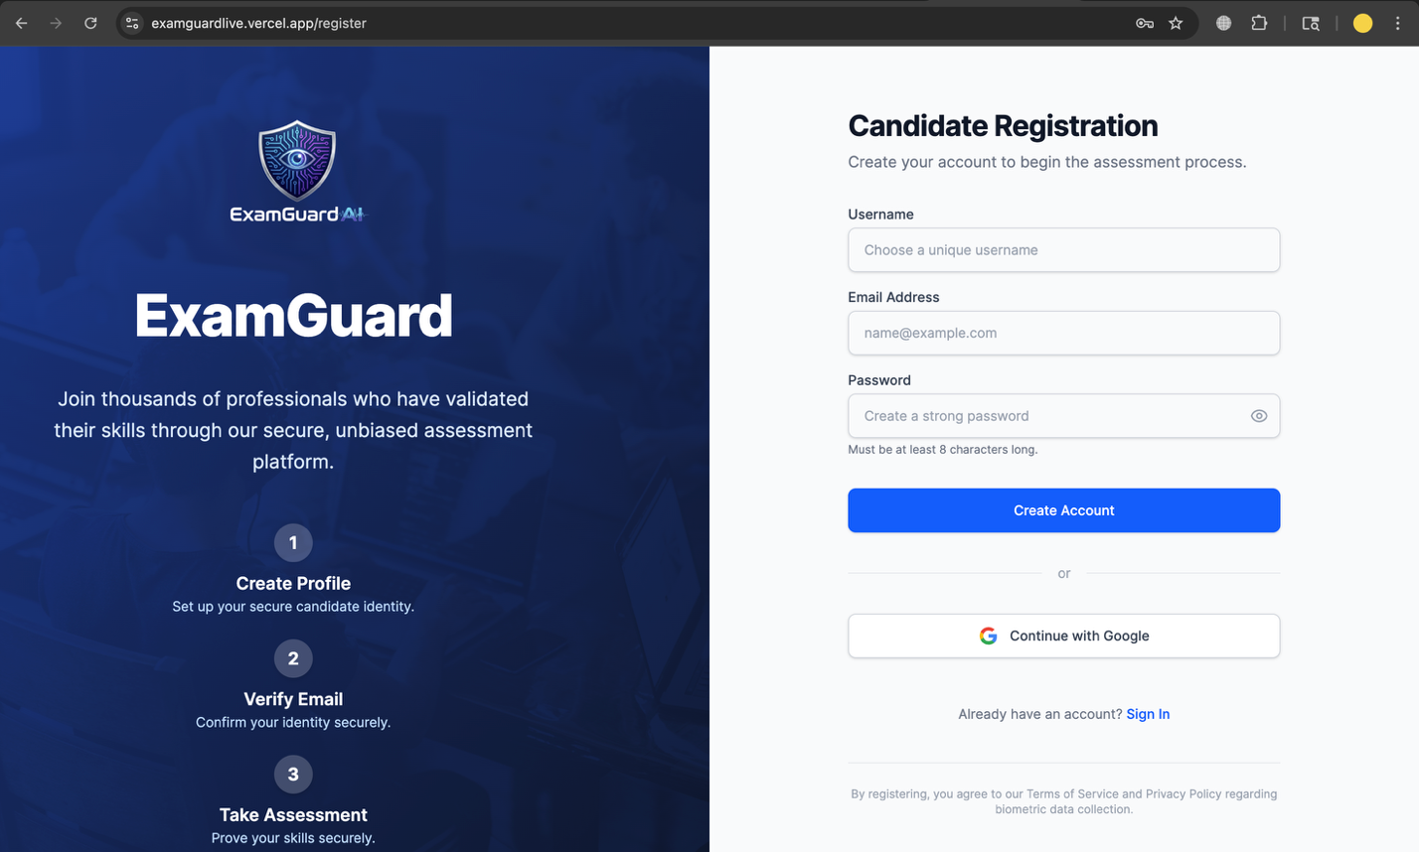

Candidate Login:

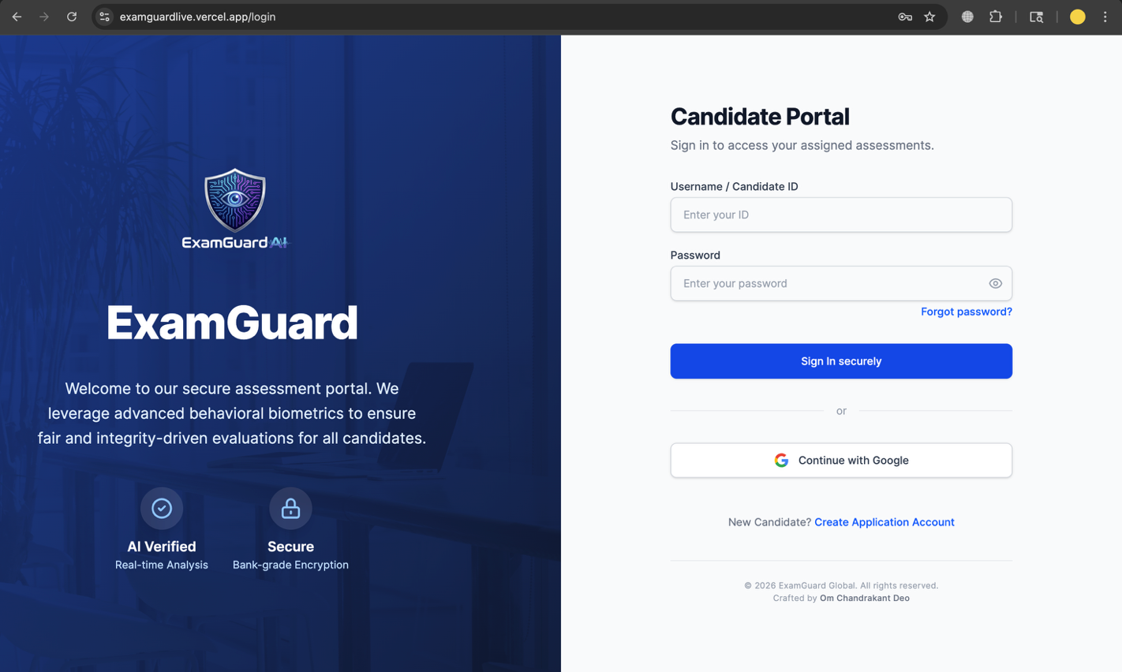
Admin Login:

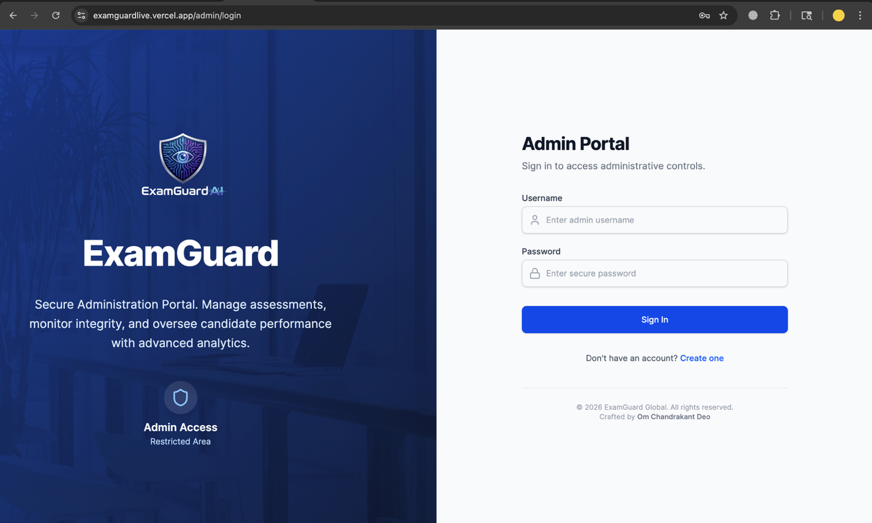

Admin Dashboard:

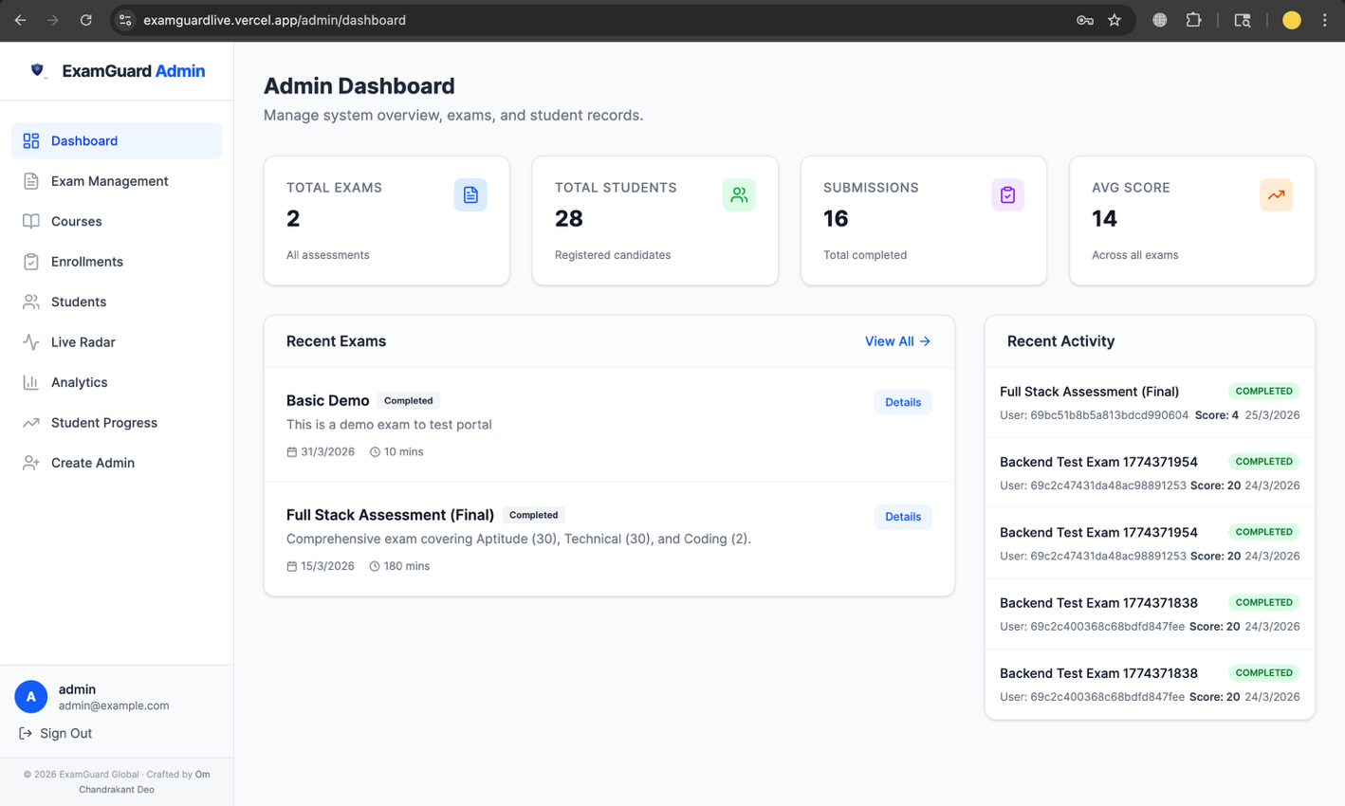

Exam Management:

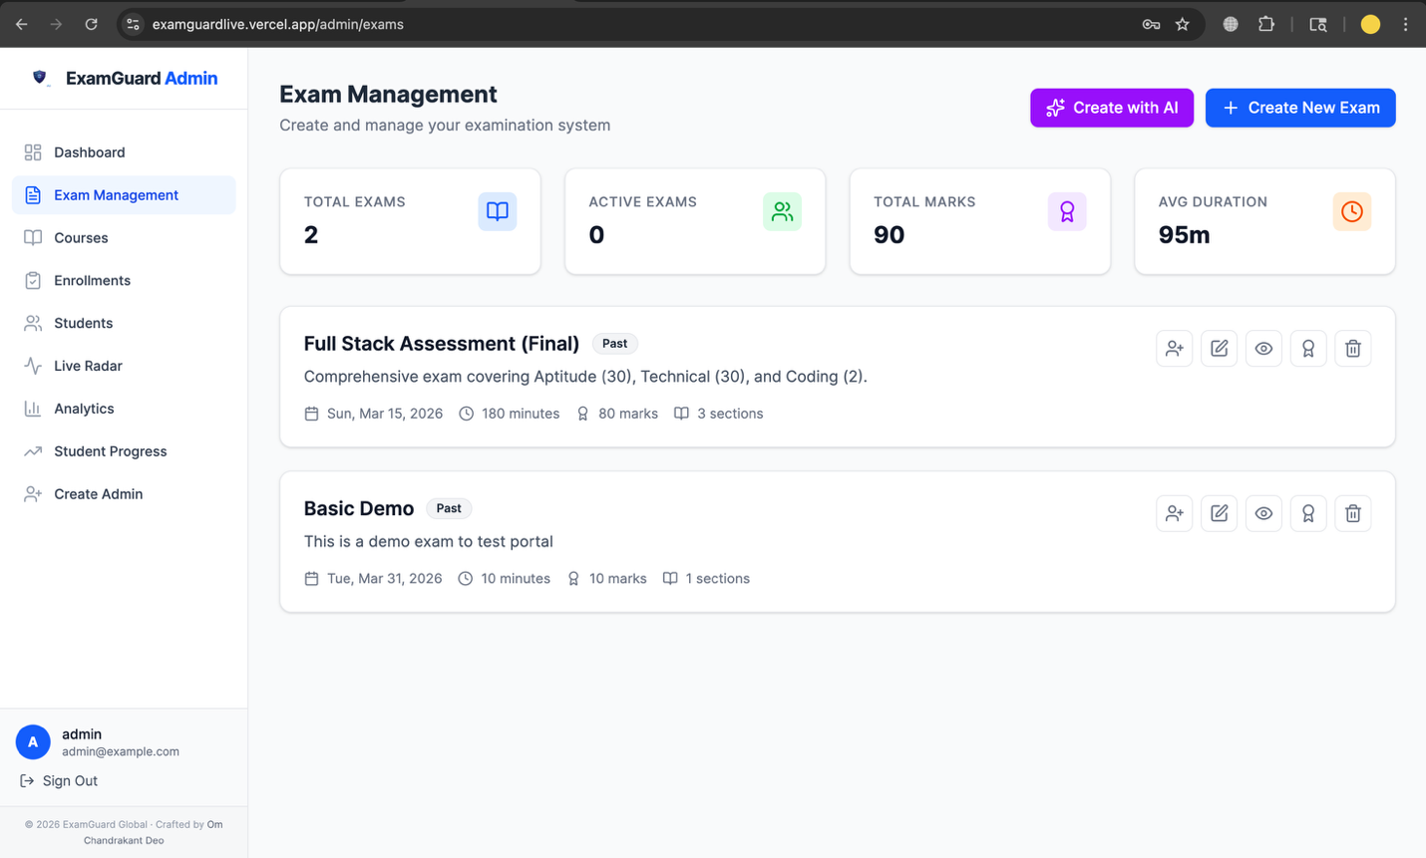

Student Management:

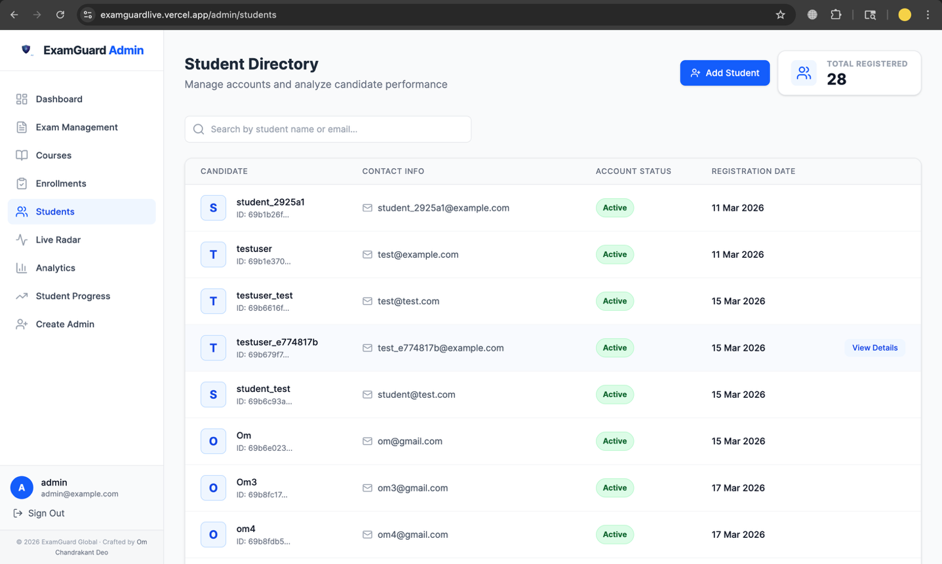

Analytics Dashboard:

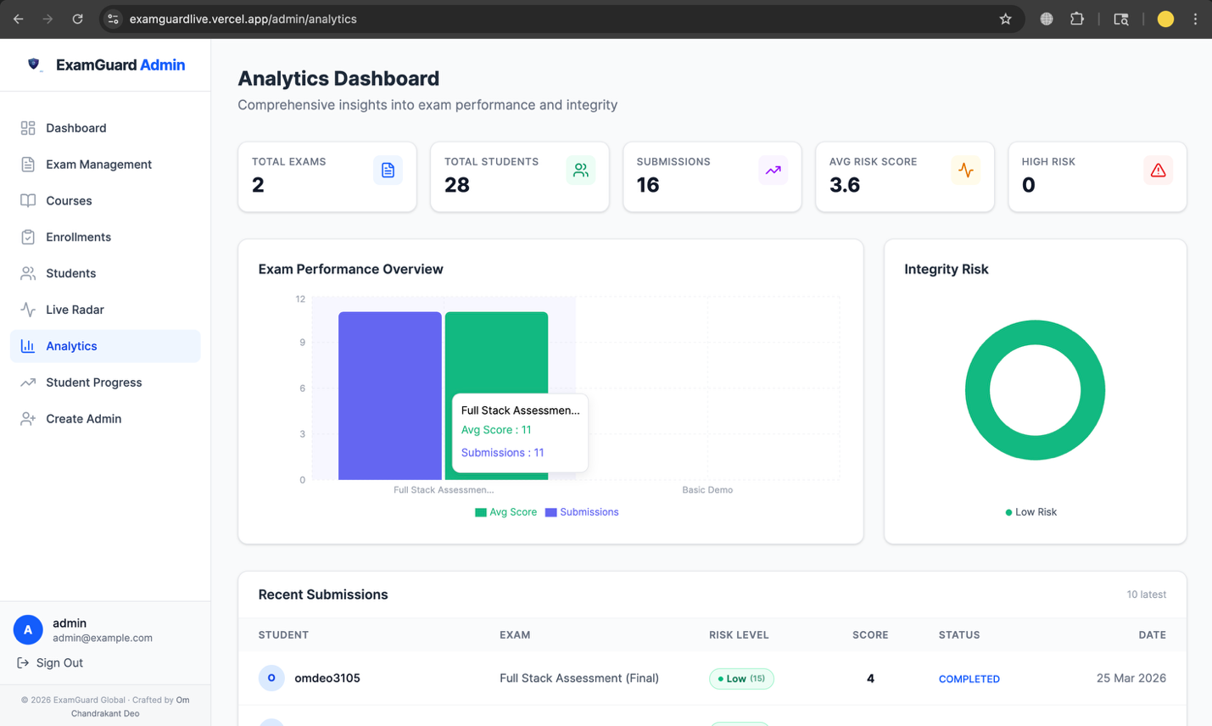

Create New Admin:

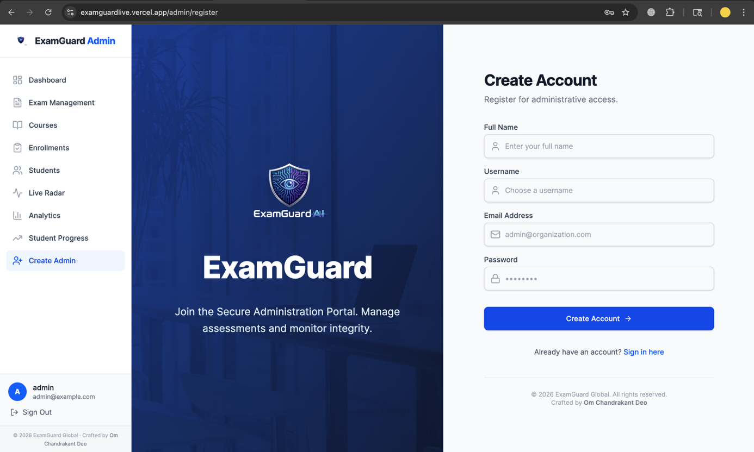

Candidate Dashboard:

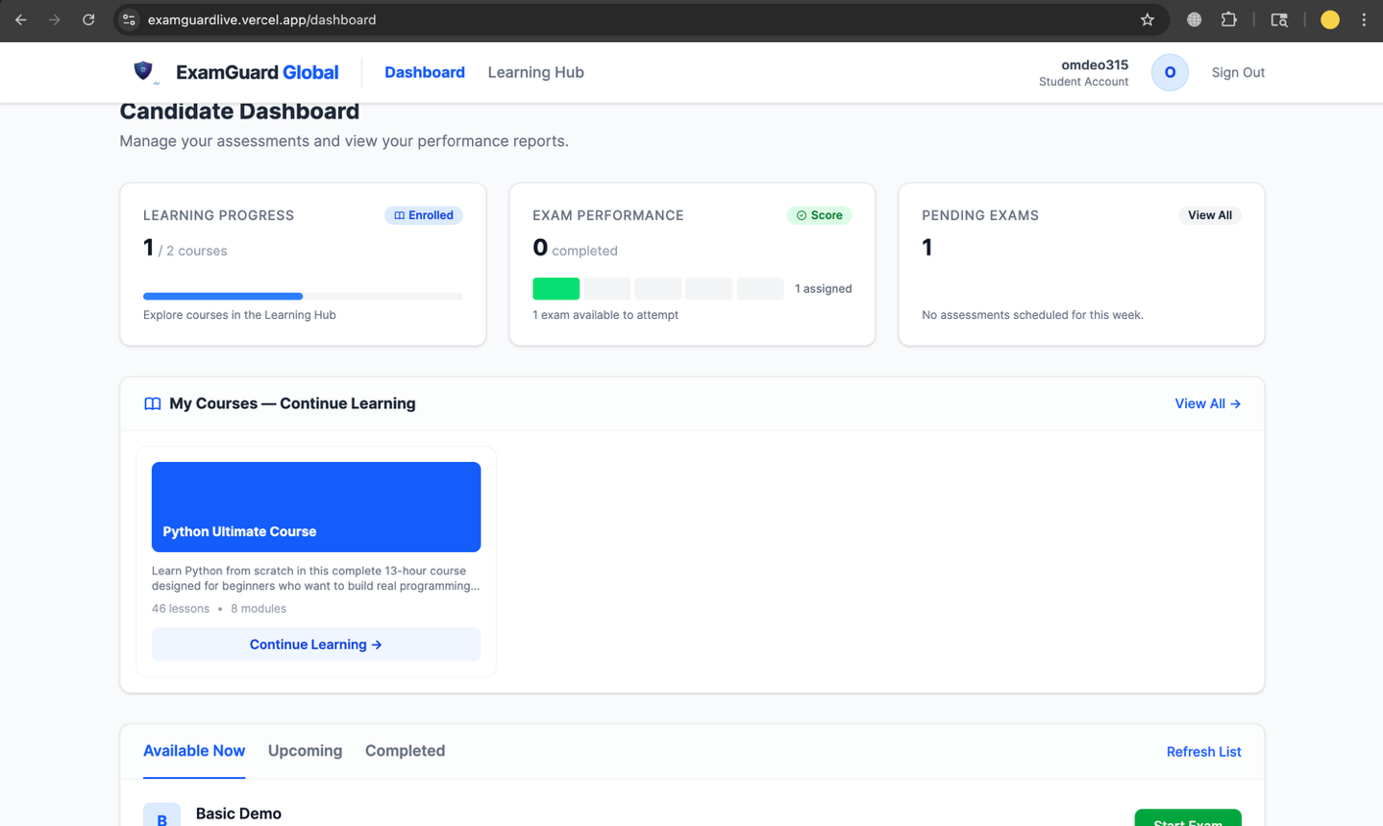
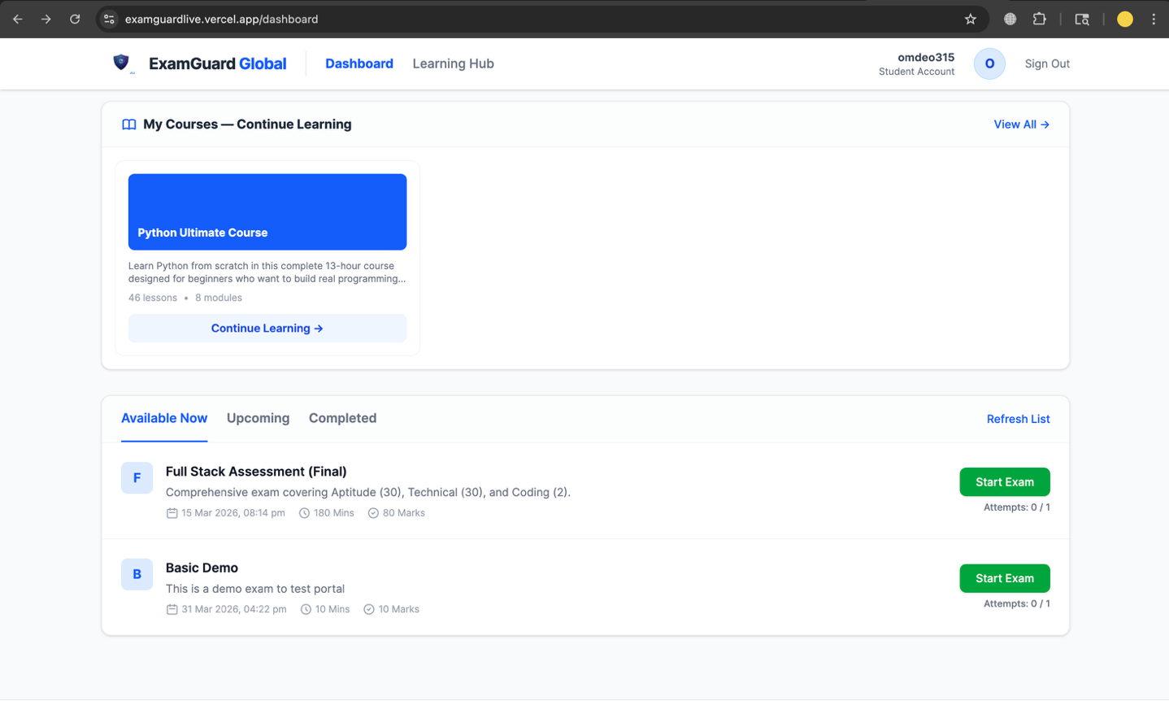

Exam Flow:

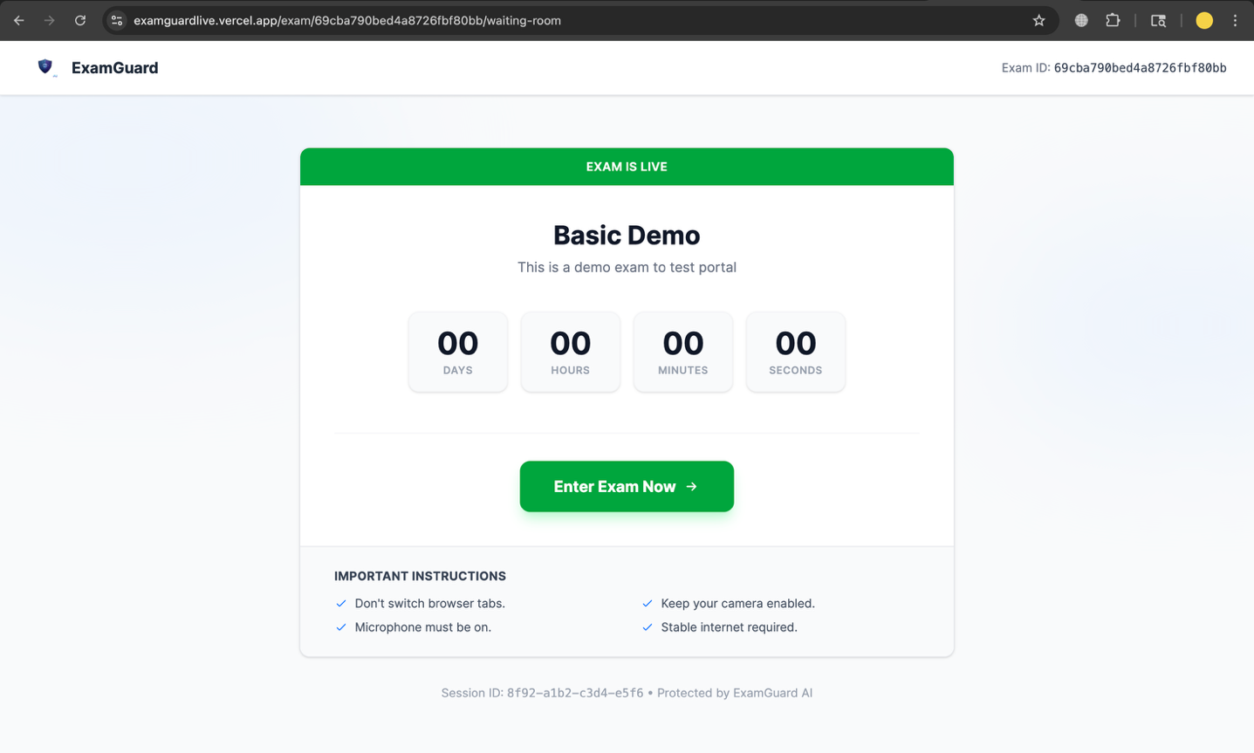
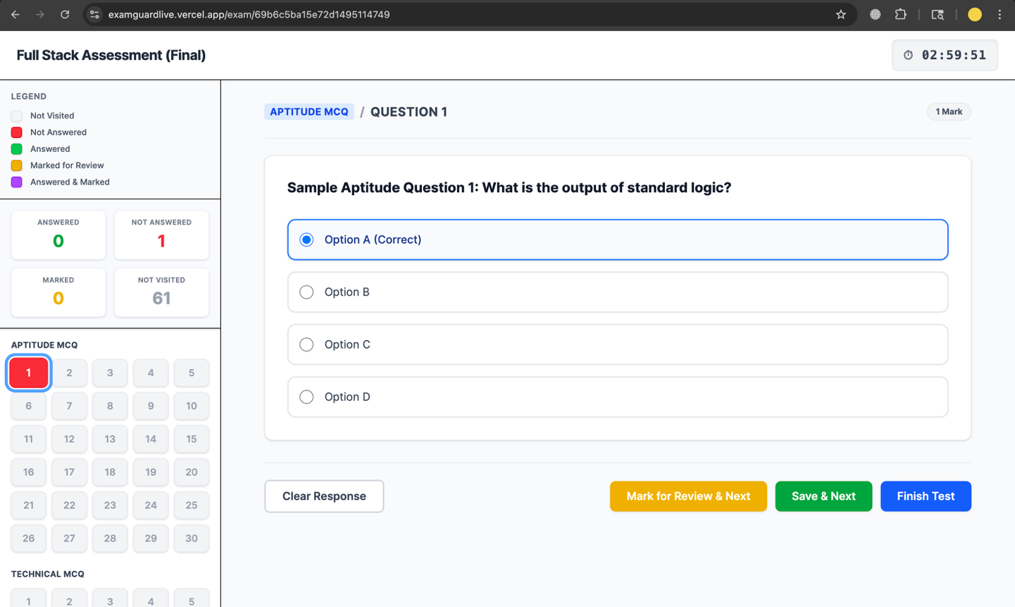

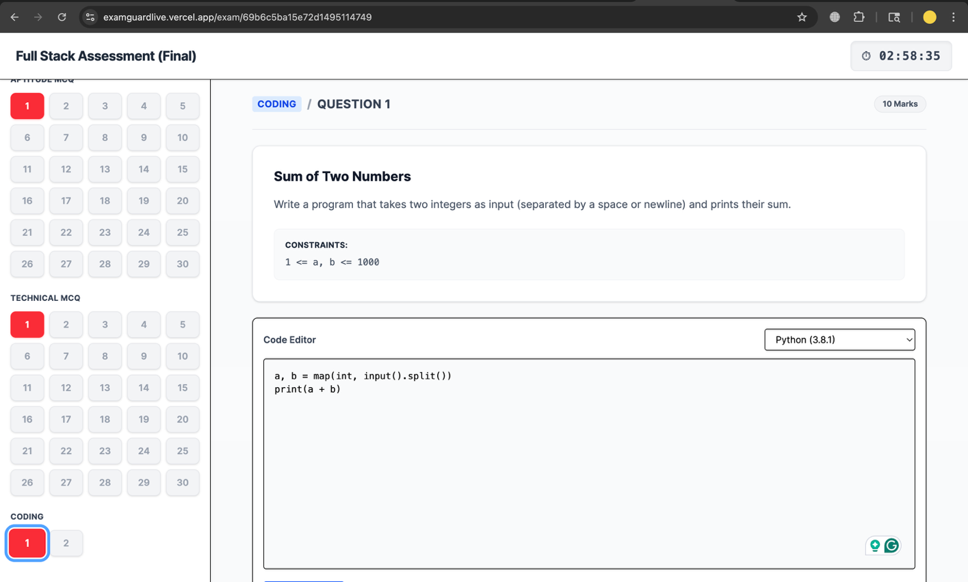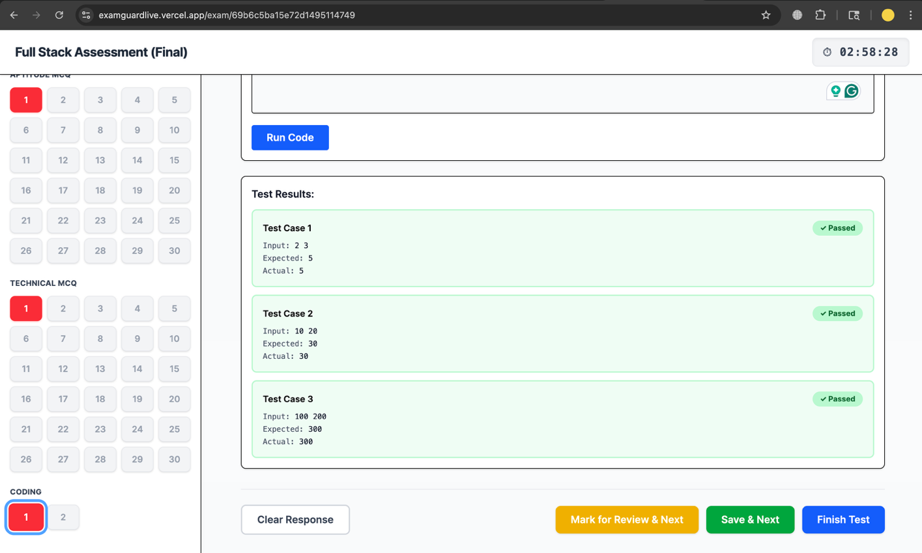


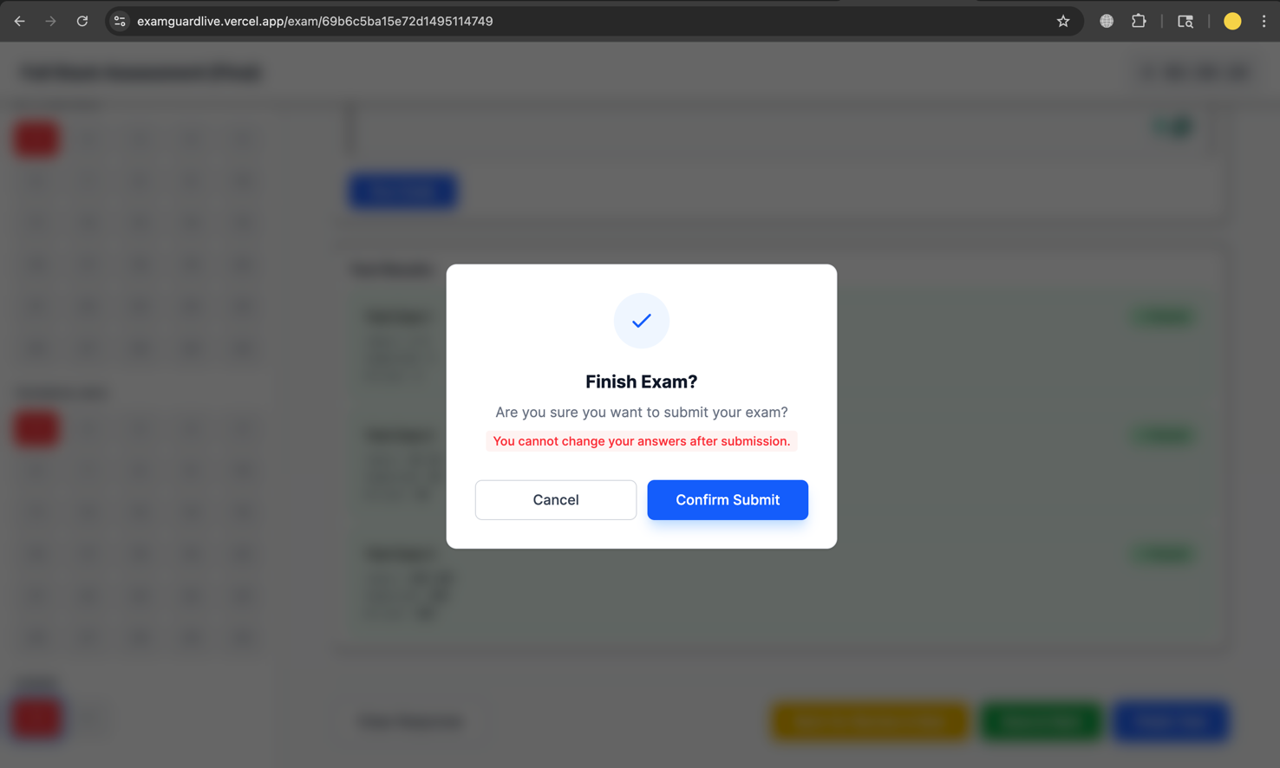

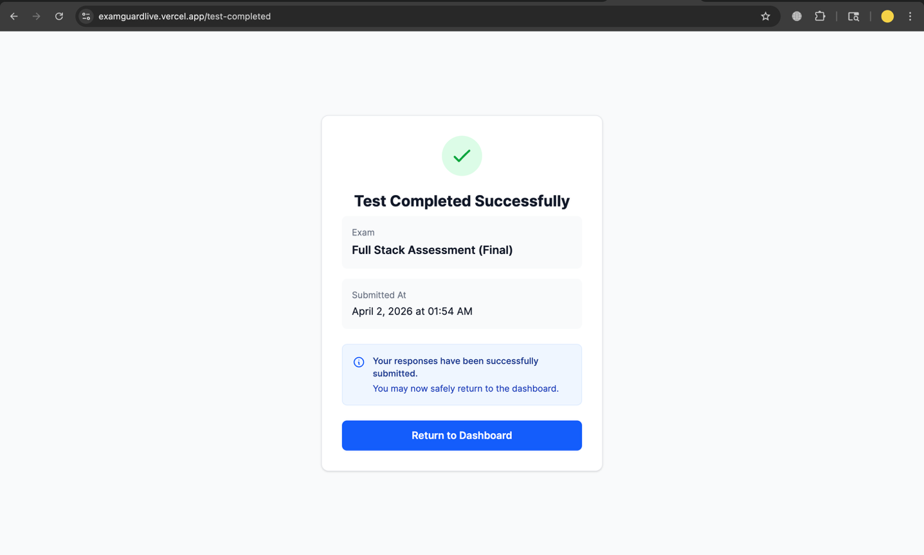

Outcomes

The following outcomes were successfully achieved by the end of the internship:
- A fully functional dual-portal web application (Admin and Student) was developed, deployed, and made accessible through public URLs, demonstrating end-to-end system integration.
- Implementation of a complete examination workflow supporting both MCQ and coding formats, including automated evaluation, result generation, and submission tracking.
- Development of a real-time proctoring system capable of detecting tab-switching, clipboard actions, and behavioral anomalies, with all violations logged and available for administrative review.
- A comprehensive Learning Management System (LMS) enabling course creation, content delivery (videos, notes, quizzes), student enrollment, progress tracking, and certificate generation.
- Creation of interactive analytics dashboards for administrators, providing insights into student performance, exam statistics, and integrity risk scores with efficient and responsive data visualization.
- Successful integration of external services such as Judge0 for secure code execution, ensuring accurate and scalable evaluation of coding assessments.
- Deployment of the system using cloud platforms (Render and Vercel), ensuring accessibility, reliability, and real-world usability of the application.
- Significant personal development in full-stack development, asynchronous programming, API integration, system design, and cloud deployment practices, along with improved problem-solving and debugging skills.

Conclusion

The internship on ExamGuard AI proved to be a highly enriching and transformative experience, effectively bridging the gap between academic learning and real-world industry practices. The project involved solving complex challenges such as designing secure multi-role authentication systems, implementing scalable backend services, integrating third-party APIs, and deploying a full-stack application to cloud platforms—all of which were successfully accomplished.
Working in a collaborative and Agile-driven environment enhanced both technical proficiency and teamwork skills. The hands-on experience with modern technologies such as FastAPI, React 18, MongoDB, and cloud deployment platforms provided a strong foundation in full-stack development and system design.
Furthermore, the project highlighted the importance of building secure, scalable, and user-centric applications in the EdTech domain. ExamGuard AI stands as a demonstration of how the right combination of architecture, technology stack, and problem-solving approach can result in a robust platform capable of meeting the evolving demands of digital education.
Overall, this internship not only strengthened my technical capabilities but also improved my ability to approach problems systematically, making it a significant step toward a professional career in software engineering.

Appendix C
Daily Work Sheet
Duration: (in Hours)
Day  No. | Activity Planned | Activity Completed  Status | Student  Signature | Mentor Signature
Day 1
Day 2
Day 3
Day 4
Day 5
Day 6
Day 7
Day 8
Day 9
Day 10
Day 11
Day 12
Day 13
Day 14
Day 15
Day 16
Day 17
Day 18
Day 19
Day 20
Day 21
Day 22
Day 23
Day 24

INTERNSHIP – DAILY WORKING REPORT SHEET

- Lab Session Details

Date | Day | Time (From – To)

- Project Information

Title of Project: | ExamGuard AI — AI-Powered Online Examination Management Platform
Objective Name
Title of Work Performing:
- Project Parameters Involved
  - Frontend ☐ Backend ☐ Database ☐ Machine Learning / AI ☐ API Integration
  - Simulation / Hardware ☐ Testing / Optimization

- Student Information

Roll Number | Student Name | Signature
- Work Done During Lab Session / Work Completion
(Describe the exact work performed during this lab duration)

- Remarks by Verifying Faculty (Satisfactory / Not-Satisfactory)

Appendix D Assignments during internship
Sr.  No. | Name of Assignment/Activity | Status  (Completed/NC) | Remark

